**AIR**

**Air**

**Air Quality Management**

**MManaMonitoring**

**Problem Statement**

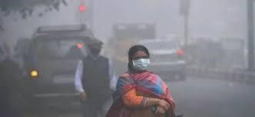To design an IOT based Air Pollution Monitoring System which used to monitor and analyse air quality real-time and log data to the cloud,keeping the data updated over the internet. Air quality measurements are taken based on the Parts per million metrics.

# Background

**In the present day, critical global issue is an air pollution which impacts negatively on the ecosystem, economy, and human health. The proposed system consists of sensors to sense harzardous**

**gases,temperature and humidity persistently and send out results to embedded controller. A simple alert and LED is used to indicate exceed in hazardous gases.**

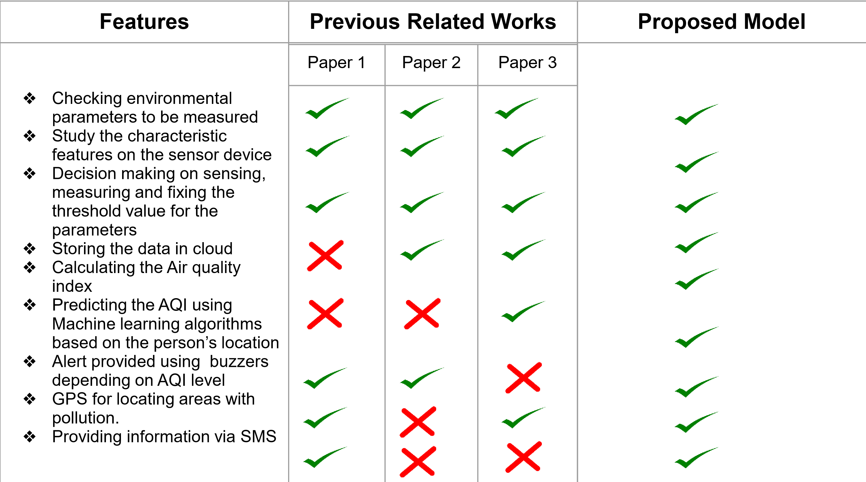**DATASET**

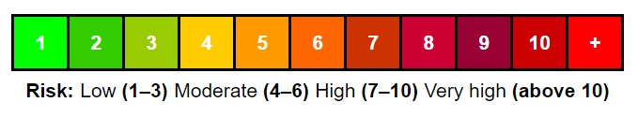

* Temperature sensor AQI calculation ● Humidity sensor and Decision

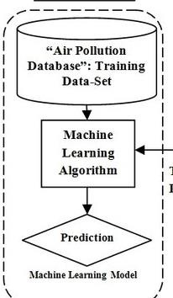

* Air Quality Gas Sensor Making

●

GPS

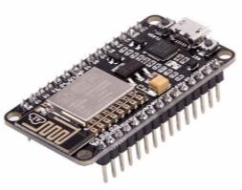

* **Sensors:**

■ MQ135 Gas sensor,

■ MQ-6 sensor (LPG sensor)

■ Temperature sensor LM35 12)

■ Humidity sensor SY-H5220

■ GPS

* Node MCU
* Arduino
* Wi-Fi module ESP8266
* Buzzer
* LED